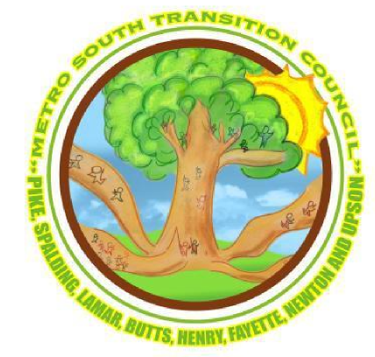

Griffin High School

1617 West Poplar St.

Griffin, Georgia 30224

Sponsors

SAVE THE DATE!

Metro South

Regional

Disability

Expo &

Transition Conference

Sat., March 5, 2016

8:00AM – 1:00PM

Exhibits open at 8:00AM

* Employment
* Day Programs
* Agencies
* Transition Resources
* Parent Resources

**LIFE AFTER**

**HIGH SCHOOL**

For students with a disability, transitioning from high school to adulthood can be a rocky path. Learn about navigating through the rocks to realize your dreams and independence.

Education Sessions start at 9:00 AM

9 am Medicaid and State Programs

10 am SSI/SSDI

11 am Employment OR Guardianship

12 pm Employment OR Guardianship

(Repeat)

Conference Chair:

Raissa Chandler

Southside Support, Inc

Email: southsideraissa@gmail.com

Phone: (770) 713-6731

More information coming soon to

http://www.msrtcconference.weebly.com

Students (middle school and up) are encouraged to come under their parent's care

(No on site childcare available)